

March 2018

Rossford

United Methodist Church
Our Mission:
"To Know Christ And to Make Christ Known"

Rossford United Methodist Church

270 Dixie Hwy

Rossford, OH 43460

Phone:

(419) 666-5323

Services

9:00 am Sunday School

10:30am Worship

Office Hours:

M-F 8:15am-2:15pm

Facebook:

www.facebook.com/

RossfordUMC

E-Mail:

rossfordumc@yahoo.com

Visit us online at:
www.rossfordumc.org

Greetings Church,

I don't know if you noticed or not, but we are now live streaming our sermon on Sunday morning. This means that we are using Facebook live to broadcast our sermon on the internet through RUMC's Facebook page and then we also post that to our website (www.rossfordumc.org). This is a neat opportunity for us as a church; we get another chance to invite our friends and family and neighbors and coworkers and fellow students to experience the love and grace and joy of Jesus Christ. So, if for some reason you can't make it to worship you can still participate with us. Also, you can invite others to watch as well.

I know inviting people to church can be a daunting task. We do not want to offend anyone, and I get that. And yet at the same time, we are people of faith who have found strength and hope and love and friendship and a place to belong and serve that has completely changed our lives for the better and we want others to experience these things as well. So, here is a great way to do that...you can like, if you haven't already, our Facebook page (www.facebook.com/RossfordUMC), and you can share RUMC's posts on your Facebook page. What a great witness that we can have on social media; reminding folks that light still shines and that love is always more powerful than hate and violence and that God is still on the move and is with us right here, right now. We can invite others through social media, we can invite others through a face to face invitation, we can invite others by the way we live (don't forget that this is the theme of our Lenten Study on Wednesday evenings at 7:00 p.m. and we are reading and learning from the book Surprise the World, by Michael Frost. I still have a few books left so come and join us as we learn to surprise our world with the love of Jesus Christ.).

I also want to take this opportunity to thank Troy Westfall and Jeff Comely, who are our media guys, who make this new opportunity possible. They do an amazing job and I am grateful for all they do for us as a church. Thanks guys for doing such an amazing job!

As we continue to move our way through this season of Lent, the 40 days that lead up to Easter, we will be exploring on Sunday mornings why our theology matters. Theology is simply the study of God, and what you know and believe about God impacts and directs how we live. What we believe, drives what we do. We will be exploring some of the big concepts of our faith and why they matter to us. See page 2 for dates about our continued sermon series on "why theology matters"

May you know that the Risen Christ is with you and loves you beyond your wildest imagination!

Grace and Peace,
Pastor Dwayne

Inside This Issue:

Pastor's Message 1

DOCK/Children's Choir 2

How can you help / Celebrations/Thanks 3

Worship and Fundraising 4

Congregational Care Committee 5

Calendar 6

Sermon Series for the month of March

"Why Theology Matters"
3/4 - "Salvation"
Luke 19: 1-9
3/11 - "Reconciliation"
Matthew 5:21-24
3/18 - "Prayer"
John 17: 20-26
3/25 - (Palm Sunday) "Atonement"
Romans 3: 21-31
3/29 - (Maundy Thursday) "A New Command"
John 13: 31-38
4/1 - (Easter) "He is Alive"
Mark 16: 1-8

JOY CARDS
We want share the message of what joy is to us.
Please take one or a few to pass out to strangers, waitresses, or anyone you
come across that you would want to share your joy with.
On the back there is a spot to write a personal message or even an invite to
join us for worship. You can find them on the table by the nametags in the Narthex.



Joy is…

"Joy is prayer; joy is strength; joy is love"
Mother Teresa

God is love
God loves you

DOCK News

- We postponed the Dessert Auction/Talent Show due to ice!!!!! Our new date is March 4th following worship. Lunch will be provided. Remember to bring a dessert for the auction. Special acts will be “sprinkled” throughout. The proceeds will be split between the youth group and the Katrina Relief mission trip. Our mission workers are Jerry Baumgartner, Mike Hoffman and Bob Ball.
- I’m trying to arrange an overnight in Columbus on March 9th to see a production of “Godspell”. Plans are still being made.
- Our Christian Passover celebration will be during our D.O.C.K. meeting on March 18th. This has become a tradition for our youth.
- Lastly, our youth led worship will be March 25th, Palm Sunday.

CHILDREN’S CHOIR
We will be sharing our song “Love, Love, Love” with you at worship on March 18th. Please come on support the youngest singers of RUMC!

Terri Seibold
Director of Youth Ministry
Disciples Of Christ’s Kingdom!



Did you know RUMC now videos the sermons each week? We've placed a link on the Rossfordumc.org website for you to view and share with others or check out our Facebook page (www.facebook.com/rossfordUMC)

Sunday March 11th, 20118

Ushers and Greeters
Please see Bob Baughman to Usher or Brenda and Al Weis to Greet or Valet.

Helping Hands of St. Louis
Thursday, April 5th, 2018. Questions please contact Jerry Baumgartner at 419-666-7236.

Prayer Quilts
If you know of anyone who would benefit from a prayer quilt please call or see Nancy Stonerock.
She can be reached at 419-874-3504.

UMC Market
The United Methodist Church has started a "market." This is a way for our church to earn money. You need to go online to www.umcmarket.org and sign up. Whenever you order from this site our church receives a % of what you purchase. There are 89 pages of participating stores and the amount we receive varies. Any questions, see Sue Perkins.

Box Tops and Stamps
We are still collecting Box Tops for Education and cancelled postage stamps. The collection box is located in the Narthex. Please see Barb Chesson if you have any questions.

Can Drive

We would like to remind you that we are still collecting aluminum cans to raise money for our church. If you have any to donate, the container is outside the kitchen door. If you need a pickup, please call Doug Williams at 419-661-9484.

Kroger Rewards
Program
The Kroger Rewards Program is a nationwide program that lets loyalty card holders select charities to which Kroger will donate, based on dollars they spend in stores. If you have a Kroger card, PLEASE check to see that you are signed up so that our church gets a percentage of what you buy. We get a check quarterly from Kroger.
Our Kroger Plus Rewards Organization
# 84283



Meeting Night for March

Tuesday - March 13th, 2018
6:30pm SPRC
6:30pm Trustees and Finance
7:30pm Admin

Contact your council chair if you have questions or can't make the meeting

MARCH CELEBRATIONS

Anniversaries

Bill & Cheryl Garlow 3/14

Mark & Darlene Limmer 3/18

Steve & Carol Kotecki 3/25

Birthdays
Shirley Ball 3/1
Dawn Bashaw 3/2
Ron McCamey 3/3
Zach Sutter 3/3
JeanE Waggoner 3/3
Alex Vargo 3/9
Martha Seal 3/10
Matt Foster 3/11
Michelle Sutter 3/17
Pete Petersen 3/21
Mary Slomski 3/21
John Rust IV 3/29
Isaiha Shugert 3/31



Thank you to everyone who donated blood during our February 16th blood drive at RUMC. We had a goal of collecting 20 units and ended up collecting 21! The American Red Cross is struggling with a blood shortage due to the recent flu season being so bad. Consider donating if you are able.



FUNDRAISING NEWS

Volunteers Needed
As you look at these events you realize that they are not a one person project, or even a five person project. So please put these dates on your calendar and plan on helping any time you are able to.

The fundraiser committee met and have set several dates for 2018.

Spring Rummage Sale - April 26th to 28th.
Set up begins April 15th

Spring BBQ - May 6th.
Set up begins May 2nd

Fall Rummage Sale - September 27th to 29th.
Set up begins September 16th

Fall BBQ - October 7th
Set up begins October 3rd

Christmas Bazaar - Saturday, November 17th
Set up the week before *previous date printed in February was incorrect*

If you have any fundraiser ideas, please see me.

Thank you!
Sue Perkins
Chairperson

Worship News
Even though the gloomy and cold season we've been through would deny it, Easter is on the way! Below you will find the calendar for March and Easter is on April 1 this year. (No fooling!) As usual, we will have Palm Sunday, Maundy Thursday, Easter Sonrise, Easter breakfast, and Easter worship services. Pastor Dwayne also has a great set of sermons for us in March entitled "Why Theology Matters." Come to worship every week and bring your friends!

March calendar:

March 4th - "Salvation" and Holy Communion
March 11th - "Reconciliation"
March 18th - "Prayer," Children's choir sings
March 25th - Palm Sunday Worship led by the Youth, "Atonement"
March 29th - Maundy Thursday, tenebris service with communion, "A New Command"
April 1st - Easter Sonrise Service at 8 AM
Easter Breakfast at 8:30 *sign up sheet in the narthex*
Easter Worship with bells, choir, blossoming of the cross at 10:30
*Don't forget to bring live flowers for the cross
April 8th - Holy Communion (delayed one week due to Easter and communion on Maundy
Thursday

There will also be an opportunity to sign up for a spring flower to put in the Memorial Garden on Easter Sunday. Watch for that. Next Worship Meeting will be April 26th at 6:30PM.

With Love,
Cheryl Garlow and Nancy Rust
Co-Chairpersons of Worship Committee
Toledo Walleye - FAITH AND FAMILY NIGHT
March 24th

Join us for a special pregame Faith and Family event on Saturday, March 24th before the Toledo Walleye vs. Brampton Beast game. This special pregame event will include an opportunity for church groups and individuals to hear directly from Team Chaplain, Tom Fraser, and select Walleye players as they discuss their faith and their experiences as professional athletes. Keynote speaker will be former University of Toledo and NFL quarterback, Bruce Gradkowski! Tickets are $17 per person which includes pregame event and admission to the game.
Signup in the Narthex if you are interested by March 1st


Shugert Surprise Adoption Party
February 18th, 2018

Congregational Care Committee
*Formally known as Hospitality and Fellowship*

Greetings from the Congregational Care Committee,

Yes we have a new name but are still the same purpose! Kim suggested that we combine both Hospitality and Fellowship together since so many of our activities and ministry run side by side! We think it's a great idea and will be easier when wondering what committee a certain expense falls under etc! Our name may have changed but we still are the same people: Al and Brenda Weis, Kim Weyandt co-chairs, members are Darrel and Caroline Eschedor, Betty Dowell and Sue Perkins still chimes in for things too! We are glad to have her wisdom and knowledge!! We certainly welcome anyone's help and like we all know it takes all of us to pull off a function or job around RUMC!! The more the merrier!!

Last Sunday we formally welcomed the Shugert's to RUMC with a "surprise" adoption lunch after worship! Grace helped us by making sure her parents were there and of course we were happy all 7 were in good health!! A fun time was held by all and our committee presented the family with a shadow box filled with puzzle pieces signed by our congregation. We also made personalized adoption t shirts for each of them. Thank you to Betty Woods for the lovely flower arrangements that went home with the family. Special thanks to Bethany Rust and Charlene Feltner who helped with food serving and cake cutting and to everyone who brought a dish to pass! Next time we do a function we should have recipes to share!!

Valet for March: Darrel Eschedor
Greeter for March: Caroline Eschedor

Craft night still continues to be a fun time to get together. The next one will be Tues March 20th in the parlor at 6:00 PM.

The Walleye Game is going to be on Sat. March 24th. Currently we have 14 people attending. This is a first time event for us but looking forward to a good game and hearing some testimony from the coach and other staff members. Money is due to Brenda Weis at $17 per person.

The pallet painting event may be postponed until later this spring as we have a conflict with the annual spring rummage sale in April. It's great that our church is so busy!!

Thank you all for your continued help and making our committee a success in honoring God by welcoming all to our church!

Sincerely,
Al and Brenda Weis, Kim Weyandt,
Congregational Care Committee co-chairs

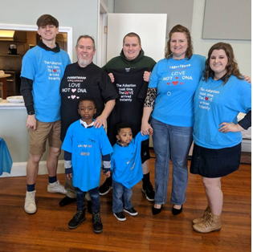

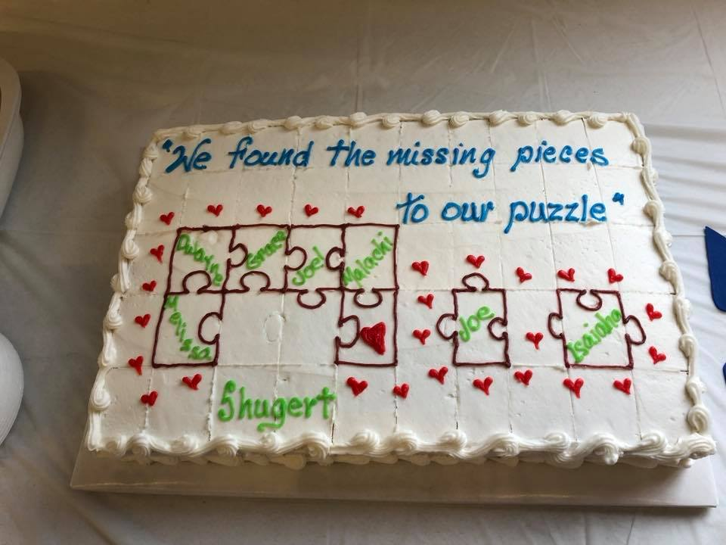

Thank You

Thank you church for all your love and prayers for us as a family. The adoption party was amazing and we are very thankful and blessed to be a part of such a wonderful church!

Love and prayers,
Pastor Dwayne, Melissa, Grace, Joel, Malachi, Joe, and Isaiha




Sunday | Monday | Tuesday | Wednesday | Thursday | Friday | Saturday
 |  |  |  | 1 | 2 | 3
6:00pm Bells
7:00pm Choir
8:30pm AA
4 | 5 | 6 | 7 | 8 | 9 | 10
9:00am Sunday School  10:30am Worship  Talent Show/Dessert Auction  No DOCK | 6-10pm Parent Project (Parlor)  8-10pm HEMA (FLC) | 9:15am Ladies Bible Study  6:30pm Cub Scouts | 6:30pm Boy Scouts  7:00pm Lenten Study (Parlor) | 6:00pm Bells  7:00pm Choir 8:30pm AA |  | 9:00am Men's Breakfast @ Silver Moon  7:30 pm Contra Dance (FLC)
11 | 12 | 13 | 14 | 15 | 16 | 17
9:00am Sunday School  10:30am Worship  Birthday Month Celebration after services  5:00pm DOCK | 6-10pm Parent Project (Parlor)  8-10pm HEMA  (FLC) | 9:15am Ladies Bible Study  6:30pm Cub Scouts  6:30pm Finance, Trustees  7:30pm Admin | 6:30pm Boy Scouts  7:00pm Lenten Study (Parlor) | 6:00 pm Bells  7:00pm Choir 8:30pm AA
18 | 19 | 20 | 21 | 22 | 23 | 24
9:00am Sunday School  10:30am Worship  5:00 pm DOCK | 6-8pm Parent Project (FLC, Parlor)  8-10pm HEMA  (FLC) | 9:15am Ladies Bible Study  6:00pm Craft Night (Parlor) | 6:30pm Boy Scouts Pack Meeting  7:00pm Lenten Study (Parlor) | 6:00Ppm Bells  7:00pm Choir 8:30pm AA
25 | 26 | 27 | 28 | 29 | 30 | 31
9:00am Sunday School  10:30am Youth Led Worship  Baptism/Birthday Party for Shugert Boys  No DOCK | 6-8pm Parent Project (FLC, Parlor)  8-10pm HEMA  (FLC) | 9:15am Ladies Bible Study  6:30pm Cub Scouts | 6:30pm Boy Scouts | 7:00pm Maundy Thursday Service  8:30pm AA


NON-PROFIT
US POSTAGE
PAID
TOLEDO, OH
PERMIT #522

ROSSFORD UNITED METHODIST CHURCH
270 DIXIE HWY
ROSSFORD, OH 43460



Staff

Pastor: Pastor Dwayne Shugert
Ministers: Every Member
Children’s Ministry: Kim Weyandt
Youth Ministry: Terri Seibold
Secretary: Jenny Graffius
Music Program Director: Sarah Buehrer
Organist: JeanE Waggoner
Custodians: Steve Agler
Jenny Riehm
Nursery: Carol Kotecki
MacKenzie Rodriguez

Lay Leadership

Lay Leader: Tom Ridenour
Head Usher: Bob Baughman
Media Directors: Troy Westfall
Jeff Comley

